Risk Assessment
Risk Assessment for the activity of | Medics Revue Show week |  | Date | 20.09.2024
Unit/Faculty/Directorate | Faculty of medicine | Assessor
Line Manager/Supervisor |  | Signed off

PART A
(1) Risk identification |  |  | (2) Risk assessment |  |  |  | (3) Risk management
Hazard | Potential Consequences | Who might be harmed  (user; those nearby; those in the vicinity; members of the public) | Inherent |  |  |  | Residual |  |  | Further controls (use the risk hierarchy)
 |  |  | Likelihood | Impact | Score | Control measures (use the risk hierarchy) | Likelihood | Impact | Score
Bumping into chairs/tables | Hurt your limbs | All members | 4 | 1 | 4 | Move chairs and tables out of the way
Tripping over/ falling during dances | Minor bruising/ scratches | All members | 3 | 1 | 3 | Wear suitable footwear
Collision with furniture when setting up rehearsal space | Minor bruising | Crew | 2 | 2 | 4 | Be aware of others whilst moving heavier furniture and keep communications clear
Minor stunts eg: cartwheels in dances | Fall and hurt yourself/ sprain | Cast | 1 | 3 | 3 | Ensure that you know how to safely do this before you perform
Tripping over wires | Fall over and hurt self | Band | 3 | 2 | 6 | Be aware of wires around you and step over them carefully. Tape wires to the ground | 2 | 2 | 4
Interaction of liquids and wires | Electrocution | Band | 2 | 5 | 10 | Ensure liquids in the band pit are in closed, leakproof containers | 1 | 5 | 5 | No liquids in band pit whatsoever
Slipping on liquid | Fall and hurt self | All members | 2 | 3 | 6 | Ensure liquids on stage are in closed, leakproof containers to avoid spillage | 1 | 3 | 3
Large bits of the set falling on members while dismantling set | Bruising, injury to limbs, scratches | Predominantly crew, however all members involved after final show | 2 | 3 | 6 | Ensure you attend StageSoc health and safety talk/ have adequate qualifications to perform these tasks | 1 | 3 | 3
Falling from heights eg: ladder, stairs | Broken bones, injury | All members | 1 | 4 | 4 | Ensure you have adequate training and permission given by StageSoc to carry out these task. Watch your step. Wear appropriate footwear.
Strobe/ disco lighting | Triggering epileptic fit in those with existing condition | Any society member/ audience with epilepsy | 1 | 4 | 4 | Publish trigger warning ahead of time.
Set collapsing eg: if built improperly/ if unstable | Physical injury from set collapsing | All members | 1 | 4 | 4 | Ensure fixtures are fitted correctly and the set is tested by qualified members eg: StageSoc, ahead of time.

PART B – Action Plan

Risk Assessment Action Plan
Part no. | Action to be taken, incl. Cost | By whom | Target date |  | Review date | Outcome at review date
1 | No liquids in band pit whatsoever | All members | N/a |  | N/a | N/a
Responsible manager’s signature:  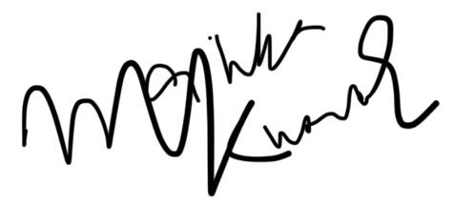 |  |  |  |  | 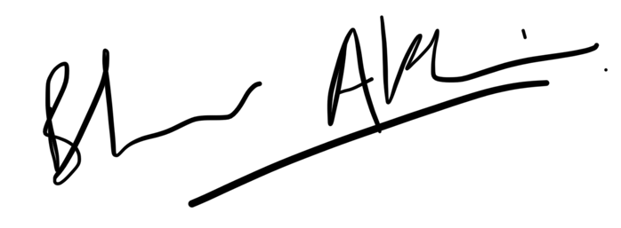  Responsible manager’s signature:
Print name: Mallika Kumar |  |  |  | Date: 20.09.2024 | Print name: Bhaavya Akhauri |  | Date:  20.09.2024

Assessment Guidance
- Eliminate | Remove the hazard wherever possible which negates the need for further controls | If this is not possible then explain why
- Substitute | Replace the hazard with one less hazardous | If not possible then explain why
- Physical controls | Examples: enclosure, fume cupboard, glove box | Likely to still require admin controls as well
- Admin controls | Examples: training, supervision, signage
- Personal protection | Examples: respirators, safety specs, gloves | Last resort as it only protects the individual
LIKELIHOOD | 5 | 5 | 10 | 15 | 20 | 25
 | 4 | 4 | 8 | 12 | 16 | 20
 | 3 | 3 | 6 | 9 | 12 | 15
 | 2 | 2 | 4 | 6 | 8 | 10
 | 1 | 1 | 2 | 3 | 4 | 5
 |  | 1 | 2 | 3 | 4 | 5
 |  | IMPACT

Impact |  | Health & Safety
1 | Trivial - insignificant | Very minor injuries e.g. slight bruising
2 | Minor | Injuries or illness e.g. small cut or abrasion which require basic first aid treatment even in self-administered.
3 | Moderate | Injuries or illness e.g. strain or sprain requiring first aid or medical support.
4 | Major | Injuries or illness e.g. broken bone requiring medical support >24 hours and time off work >4 weeks.
5 | Severe – extremely significant | Fatality or multiple serious injuries or illness requiring hospital admission or significant time off work.
Risk process
- Identify the impact and likelihood using the tables above.
- Identify the risk rating by multiplying the Impact by the likelihood using the coloured matrix.
- If the risk is amber or red – identify control measures to reduce the risk to as low as is reasonably practicable.
- If the residual risk is green, additional controls are not necessary.
- If the residual risk is amber the activity can continue but you must identify and implement further controls to reduce the risk to as low as reasonably practicable.
- If the residual risk is red do not continue with the activity until additional controls have been implemented and the risk is reduced.
- Control measures should follow the risk hierarchy, where appropriate as per the pyramid above.
- The cost of implementing control measures can be taken into account but should be proportional to the risk i.e. a control to reduce low risk may not need to be carried out if the cost is high but a control to manage high risk means that even at high cost the control would be necessary.

Likelihood
1 | Rare e.g. 1 in 100,000 chance or higher
2 | Unlikely e.g. 1 in 10,000 chance or higher
3 | Possible e.g. 1 in 1,000 chance or higher
4 | Likely e.g. 1 in 100 chance or higher
5 | Very Likely e.g. 1 in 10 chance or higher

