Risk Assessment
Risk Assessment for the activity of | Orange Army Pub Crawl 2023 (17th October) |  | Date | 04/10/2023
Unit/Faculty/Directorate | History Society | Assessor | Emma Ramsay
Line Manager/Supervisor |  | Signed off | James McCullough

PART A
(1) Risk identification |  |  | (2) Risk assessment |  |  |  | (3) Risk management
Hazard | Potential Consequences | Who might be harmed  (user; those nearby; those in the vicinity; members of the public) | Inherent |  |  |  | Residual |  |  | Further controls (use the risk hierarchy)
 |  |  | Likelihood | Impact | Score | Control measures (use the risk hierarchy) | Likelihood | Impact | Score
1. Potential fire hazards in the Stag’s; the Mitre; the Hobbit; Jesters | Severe burns. | Those in the vicinity will be at risk. | 1 | 4 | 4 | Fire control measures and fire prevention devices; fire extinguishers, alarms, blankets. | 1 | 4 | 4 | Awareness and observation by committee members and staff. Readiness to alert relevant authorities.
2. Illness from drinking, over-consumption of alcohol. | Severe illness, potentially taken to hospital. | User. | 3 | 3 | 9 | Monitored event, no initiations or other such ceremonies allowed. If an injury does occur, then first aid practices will take place and the relevant authorities will be alerted. | 3 | 2 | 6 | Over-consumption of alcohol will be discouraged. Emphasise that drinking is optional. Water is encouraged for those who do participate in drinking. Sending people home, who are excessively drunk.
3. Getting lost on the way home | Hypothermia, physically assaulted. | User. | 1 | 3 | 3 | The committee will encourage students to stay in groups and get a taxi or bus home at the end of the event. | 1 | 2 | 2 | As above. The committee will assist in making transport arrangements and will offer to walk people home if needed.
4. Drink getting spiked | Physically attacked, loss of co-ordination may require hospital treatment. | User. | 1 | 4 | 4 | We are going to safe and well-known establishments which are monitored by security. Encouraged use of drink covers when provided. Making sure that people don’t leave their drinks unattended. | 1 | 1 | 1 | Vigilance and oversight by committee and staff. Contacting the local police authorities and establishment owners if such an event does occur.
5. Minor/Major physical injury | Depends on nature of the injury, it will be with by the committee according to what is appropriate. | User and those nearby. | 3 | 3 | 9 | First aid qualified committee members, and safe environment and establishments. When moving between establishments we will endeavour to keep everyone together to reduce the risk of bodily harm. | 3 | 2 | 6 | Vigilance and oversight by the committee. Relevant local authorities will be notified should such hazards arise.
6. Fighting/brawling | Injury to those engaging in the brawl | User and those nearby. | 1 | 3 | 3 | Bystanders will be kept at bay from the brawl at a safe distance, relevant authorities will be notified such as SUSU activities and the police and the University depending upon severity. If anyone is harmed, first aid will be given until an ambulance arrives. | 1 | 2 | 2 | Vigilance by the committee as on the whole we are a very sensible society; such actions are unprecedented on our socials, but we will remain alert of the possibility. Making it clear that there is a zero-tolerance attitude to any such actions.
7. Cold night time weather. | Hypothermia and cold-related illnesses. | User. | 3 | 2 | 6 | Individuals will be encouraged to bring warm clothing and to taxi home by committee members. | 2 | 2 | 4 | Further advice against over-consumption of alcohol. Committee members will stay observant.
8. COVID-19 transmission. | Further spread of the virus; potentially serious symptoms. | All present. | 2 | 2 | 4 | Attendees will be encouraged to do lateral flow tests before coming. Anyone with symptoms will be sent home. | 2 | 2 | 4 | Continued threat of coronavirus will be emphasised and attendees will be encouraged to get double-vaccinated in advance. Committee members will look out for anyone displaying symptoms, so that they can be sent home.

PART B – Action Plan

Risk Assessment Action Plan
Part no. | Action to be taken, incl. Cost | By whom | Target date |  | Review date | Outcome at review date
1 | Should this occur, we will adhere to the management’s advice and vacate the building at the nearest exit. | Committee and bar staff. | 12/08 |  | 18/10
2 | Depending on the severity, either sent home or to the hospital. | Committee. | 12/08 |  | 18/10
3 | Making sure members are either walking in groups and getting Ubers to get home safe, to reduce the risk of getting lost or injured. Extra attention is to be paid to people who aren’t not in groups. | Committee and bar staff. | 12/08 |  | 18/10
4 | Call an ambulance and take them to the hospital. | Committee or friends. | 12/08 |  | 18/10
5 | Depending on the severity, either sent home or to the hospital. | Committee or friends. | 12/08 |  | 18/10
6 | Depending on the severity, either sent home or to the hospital. | Committee or friends. | 12/08 |  | 18/10
7 | Arrangement of transport home. | Committee or friends. | 12/08 |  | 18/10
8 | Anyone with symptoms will be sent home. If transmission becomes apparent after the event, committee will encourage all attendees to begin isolation. | Committee. | 12/08 |  | 18/10
Responsible manager’s signature: 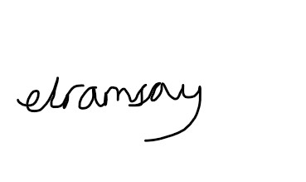 |  |  |  |  | Responsible manager’s signature: 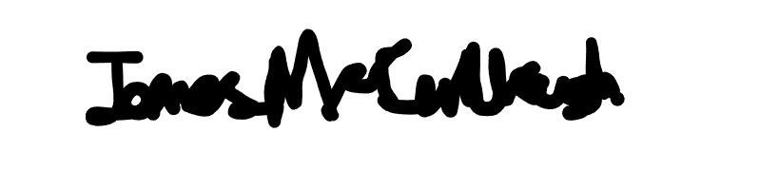
Print name: Emma Ramsay |  |  |  | Date: 04/10 | Print name: James McCullough |  | Date: 04/10

Assessment Guidance
- Eliminate | Remove the hazard wherever possible which negates the need for further controls | If this is not possible then explain why
- Substitute | Replace the hazard with one less hazardous | If not possible then explain why
- Physical controls | Examples: enclosure, fume cupboard, glove box | Likely to still require admin controls as well
- Admin controls | Examples: training, supervision, signage
- Personal protection | Examples: respirators, safety specs, gloves | Last resort as it only protects the individual
LIKELIHOOD | 5 | 5 | 10 | 15 | 20 | 25
 | 4 | 4 | 8 | 12 | 16 | 20
 | 3 | 3 | 6 | 9 | 12 | 15
 | 2 | 2 | 4 | 6 | 8 | 10
 | 1 | 1 | 2 | 3 | 4 | 5
 |  | 1 | 2 | 3 | 4 | 5
 |  | IMPACT

Impact |  | Health & Safety
1 | Trivial - insignificant | Very minor injuries e.g. slight bruising
2 | Minor | Injuries or illness e.g. small cut or abrasion which require basic first aid treatment even in self-administered.
3 | Moderate | Injuries or illness e.g. strain or sprain requiring first aid or medical support.
4 | Major | Injuries or illness e.g. broken bone requiring medical support >24 hours and time off work >4 weeks.
5 | Severe – extremely significant | Fatality or multiple serious injuries or illness requiring hospital admission or significant time off work.
Risk process
- Identify the impact and likelihood using the tables above.
- Identify the risk rating by multiplying the Impact by the likelihood using the coloured matrix.
- If the risk is amber or red – identify control measures to reduce the risk to as low as is reasonably practicable.
- If the residual risk is green, additional controls are not necessary.
- If the residual risk is amber the activity can continue but you must identify and implement further controls to reduce the risk to as low as reasonably practicable.
- If the residual risk is red do not continue with the activity until additional controls have been implemented and the risk is reduced.
- Control measures should follow the risk hierarchy, where appropriate as per the pyramid above.
- The cost of implementing control measures can be taken into account but should be proportional to the risk i.e. a control to reduce low risk may not need to be carried out if the cost is high but a control to manage high risk means that even at high cost the control would be necessary.

Likelihood
1 | Rare e.g. 1 in 100,000 chance or higher
2 | Unlikely e.g. 1 in 10,000 chance or higher
3 | Possible e.g. 1 in 1,000 chance or higher
4 | Likely e.g. 1 in 100 chance or higher
5 | Very Likely e.g. 1 in 10 chance or higher

