Risk Assessment
Risk Assessment for the activity of | TRIP – Narrow Boat in UK: Down the River Severn to Worcester |  | Date | 31/03/24
Unit/Faculty/Directorate | Southampton Universities Guild of Change Ringers | Assessor | Philippa Garraway - Master
Line Manager/Supervisor/President/Other committee member |  | Signed off

PLEASE USE THIS SECTION TO UPDATE/AMMEND/ADD ANY INFORMATION REQUIRED. IF YOU HAVE ANY FURTHER QUESTIONS REGARDING YOUR RISK ASSESSMENT PLEASE CONTACT XXXXXXXXXXXXXX FOR FURTHER INFORMATION.
PLEASE NOTE AS A COMMITTEE IT IS ESSENTIAL THAT YOU HAVE A RISK ASSESMENT IN PLACE PRIOR TO ANY ACTIVITY OR TRIP
PLEASE ADD THE FOLLOWING INFORMATION:
- Where are you going?
- Where are you staying?
- How many people are going on the trip?

- SUGCR is holding a canal boat trip this Summer from 14/06/24 to 17/06/24
- We will be travelling by car to Stourport – on – Severn, where we pick up the canal boat
- We will be travelling down the Severn to Worcester and back by narrowboat, stopping overnight in Holt, Worcester and then Lincomb (on the way back)
- Up the Birmingham and Worcester canal in Worcester
- We currently have 9 people staying on the boat

PART A
(1) Risk identification |  |  | (2) Risk assessment |  |  |  | (3) Risk management
Hazard | Potential Consequences | Who might be harmed  (user; those nearby; those in the vicinity; members of the public) | Inherent |  |  |  | Residual |  |  | Further controls (use the risk hierarchy)
 |  |  | Likelihood | Impact | Score | Control measures (use the risk hierarchy) | Likelihood | Impact | Score
Slips, Trips, Falls | Accident and/or Injury | - Students  - Members of the public | 1 | 3 | 3 | - Students will be encouraged to take care when crossing busy streets and when negotiating paths  - Students encouraged to take note of surroundings on the boat – it is narrow, and there may be a number of trip hazards, also low ceiling  - Also encouraged to take care when embarking/disembarking the boat – take care on gangplanks  - Students encouraged to take care and make use of railings when going up towers  - Students will also be encouraged to wear appropriate footwear when travelling by foot | 1 | 3 | 3 | - Should injury occur, Committee to contact appropriate emergency services  - Organisers to bring a first aid kit for minor injuries  - Committee to report to SUSU Duty Manager as soon as possible
Individuals getting lost while on the trip. | Missing booked towers or during meals | Students/ people on the canal boat | 2 | 3 | 6 | - Everyone to have organiser’s contact number and group chat set up before trip for easy communication  - Everyone to receive a copy of the itinerary, including specific meeting points and timings  - Only licensed taxi companies such as Uber shall be used, as well as reliable public transport links | 1 | 2 | 2 | - The phone numbers of the committee members in attendance have been given to everyone on the trip. Social media contact is also available via the WhatsApp group and chat.  - The committee will keep everyone together and periodically conduct group counts at important sections of the trip (i.e. before setting off from stopovers, at towers)
Transport: Cancellation/Diversions | Students not reaching intended destination | - Students/ those on boat | 3 | 1 | 4 | - Prior to trip, contact with narrowboat company to ensure plans are going ahead (they should contact the organiser 7 days beforehand)  - Check weather updates  - No night driving on canal  - Back up plan – if river off limits, travel up Staffordshire and Worcestershire canal to Kidderminister  - Cancellation and curtailment insurance | 3 | 1 | 4 | - During the trip, the committee to remain in contact with narrow boat company in case of changes to plan  - Constant weather monitoring and evaluation of situation
Travelling around location | Large groups forming | - Students  - Members of the public | 3 | 2 | 6 | - split students into smaller groups to avoid large groups forming  - students encouraged to be aware of surroundings | 3 | 1 | 4 | - Organisers to familiarise self with location and destinations in advance. Itinerary provided where possible, also provide google map with key locations pinpointed
Traffic- accident or collision (boat and car) | Death or major injury | - Students  - Members of the Public | 1 | 5 | 5 | - Seatbelts to be warn all times in cars  - Student drivers- The driver will need to be familiar with driving regulations and comfortable with driving passengers.  - It is important to verify that the driver has the correct licence and insurance  - On the boat, ensure non – confident drivers are supervised by those who are confident  - Training from canal boat company provided  - Brief everyone on mooring and departure protocol  - Ensure there are multiple people keeping watch when manoeuvring the boat  - No steering when reversing the boat  - Students to be briefed on canal/river safety and driving regulations  - No narrowboat driving at night  - Encourage students to use pedestrian crossings wherever possible  - Encourage students to travel in appropriate group sizes to ensure no large groups are formed  - Work on foot planned to avoid fast roads wherever possible. | 1 | 3 | 3 | - Contact local emergency services  - Ensure all are aware of the Canal and River trust emergency number - 0800 47 999 47  - Gather all evidence and complete the incident form - If the Duty Manager is not present the incident report must be filled out immediately, it can be found on the SUSU website here.- https://www.susu.org/contact.html  - Ensure the correct insurance is in place
Adverse Weather | Sunstroke, heatstroke, cold, minor illnesses as a result of weather | - Students | 1 | 2 | 2 | - Advise students and helpers to take appropriate clothing i.e. waterproofs, hat, sun cream, sunglasses | 1 | 1 | 1 | - Should weather be deemed ‘adverse’ this tour will be cancelled
Risk of Violent Crime, harassment and/or abuse | Accident and or injury | - Students  - Members of the public | 1 | 4 | 4 | - Students will be encouraged to stay in groups at all time.  - All to be aware of emergency contact numbers either 999/111 or 0800 47 999 47  - Stay away from large gatherings or demonstrations  - Advise participants to use common sense when getting into vehicles, or accepting invitations and to get out of the vehicle if they feel at risk  - Participants all advised to give up their valuables in the event of a confrontation to prioritise own safety | 1 | 3 | 3 | - Should a student witness or be a victim to such crime they are able to contact the appropriate emergency service and report to the committee. In turn this to be reported to the duty manager  - Report incidents to local emergency services  - In the event of injury, seek medical attention, or use of First Aid kit carried by committee  - Gather all evidence and complete the incident form - If the Duty Manager is not present the incident report must be filled out immediately, it can be found on the SUSU website here.- https://www.susu.org/contact.html
Loss of valuables | Lost items | - Students | 2 | 1 | 2 | - All attendees will be warned prior to the trip to keep valuables secure and hidden  - Advise participants to have access to personal emergency money, for food/water/travel in the event of robbery, e.g. via telephone  - Stay away from large gatherings or demonstrations  - Advice students to carry a minimum of valuables | 2 | 1 | 2 | - Ensure each participant has booked appropriate insurance for the duration of the trip and has access to insurance details
Students becoming lost | Distressed students | - Students | 2 | 1 | 2 | - Should student become lost, students will be encouraged to message the committee through designed chat. Whatsapp  - Encourage all participants to swap numbers before trip | 2 | 1 | 2 | - Students will be encouraged to stay in groups at all time.  - Organisers to share trip itinerary were applicable
Inappropriate behaviour – from others or students | Distressed students, members of the public | - Students  - Members of the public | 1 | 1 | 2 | - Should inappropriate behaviour occur, students can contact both SUSU and/or appropriate emergency services  - Alcohol: members to follow SUSU expect respect guidance, binge drinking to be discouraged, participants encouraged to buddy up and be sensible/use common sense when drinking e.g. do not leave drinks unattended, do not drink to excess, use licenced premises | 1 | 1 | 2 | - Ensure participants are aware that they are responsible for own behaviour (e.g. if arrested), share SUSU expect respect policy in advance of trip  - Report all incidents following SUSU incident reporting guidelines  - Contact emergency services if required  - Ensure participants have appropriate insurance and access to mobile phone
Incident- Experience of terrorism | Distress, serious injury, fatality | Students  Public  Wider student community etc | 3 | 5 | 15 | - In case of an incident follow Run, Hide, Tell guidance. follow the advice of in-country energy service  - Stay away from large gatherings or demonstrations  - Mobile phone access- ensure chargers are taken and research has been done onto local adapters, network access | 2 | 5 | 10 | - Ensure each participant has booked appropriate insurance for the duration of the trip and has access to insurance details  - Emergency services contact if required
Incidents restricting travel and health- Natural Disasters, pandemics, political incidents | Distress, serious injury, fatality, inability to return home | Students  Public  Wider student community etc | 3 | 5 | 15 | - Stay away from large gatherings or demonstrations  - Mobile phone access- ensure chargers are taken and research has been done onto local adapters, network access  - Each participant to have at hand details and list of local emergency phone numbers  - Regular checks with narrowboat company prior to departure | 2 | 5 | 10 | - Ensure each participant has booked appropriate insurance for the duration of the trip and has access to insurance details  - Contact emergency services if required
Medical Emergency | Participants may sustain injury due to; pre-existing medical conditions, an incident whilst travelling, or as a result of a poor response to a previous medical situation. | Student participants | 3 | 5 | 15 | - advise participants; to bring their personal medication, what numbers to ring in an emergency, and that the priority is to first seek medical attention (not to call home first!)  - Advice participants to bring enough medication for trip duration and include ingredients list, packaging (to support in country medical team if required)  - Next of kin and medical details have been collected in case they are needed for medical reasons- stored securely following GDPR Guidelines  - Organisers to familiarise self and brief participants on local medical facilities – nearest A&E is Worcestershire Royal in Worcester | 2 | 5 | 10 | - Ensure each participant has booked appropriate insurance for the duration of the trip and has access to insurance details  - Contact emergency services if required
Drowning- tours/trips by the sea, lakes etc, activities involving water | Serious injury/fatality | Student participants | 3 | 5 | 15 | - Participants to obey local laws and follow local advice on tides  - Ideally swimming should be avoided  - Advice common sense- Participants undertake activities at own risk- encouraged to think about own ability e.g. swimming competency and training (water sports) – survey for swimming ability to identify high risk individuals on boat  - Life jackets/PPE to be worn as instructed, and made available on the narrowboat  - Swimming at night to be avoided | 2 | 5 | 10 | - Ensure each participant has booked appropriate insurance for the duration of the trip and has access to insurance details  - Contact emergency services if required  - Ongoing dynamic risk assessment taking into account location and weather  - If someone goes overboard, Canal and River trust advice is to throw a life ring and call for help – ensure no one jumps in after them

PART B – Action Plan

Risk Assessment Action Plan
Part no. | Action to be taken, incl. Cost | By whom |  | Target date | Review date | Outcome at review date
1 | Organisers to ensure appropriate travel insurance has been secured by/for each participant/ to cover trip | PG
2 | Participant briefing on health & safety before trip e.g. meeting, online, emails (including emergency services information on and off river) | PG
3 | Trip itinerary and details of timings and towers shared with all participants | PG
4 | Participants emergency contact details gathered by organisers- stored securely in accordance with GDPR guidelines | PG
5 | Organisers to check and pack a first aid kit | PG
6 | Organisers Severe Weather and Natural Disaster Check prior to departure | PG
7 | Transport- where student drivers and hire vehicles to be used ensure company vehicle safety checks area carried out, and research laws on licencing  Book appropriate travel insurance/cover | PG - +drivers
Responsible manager’s signature:  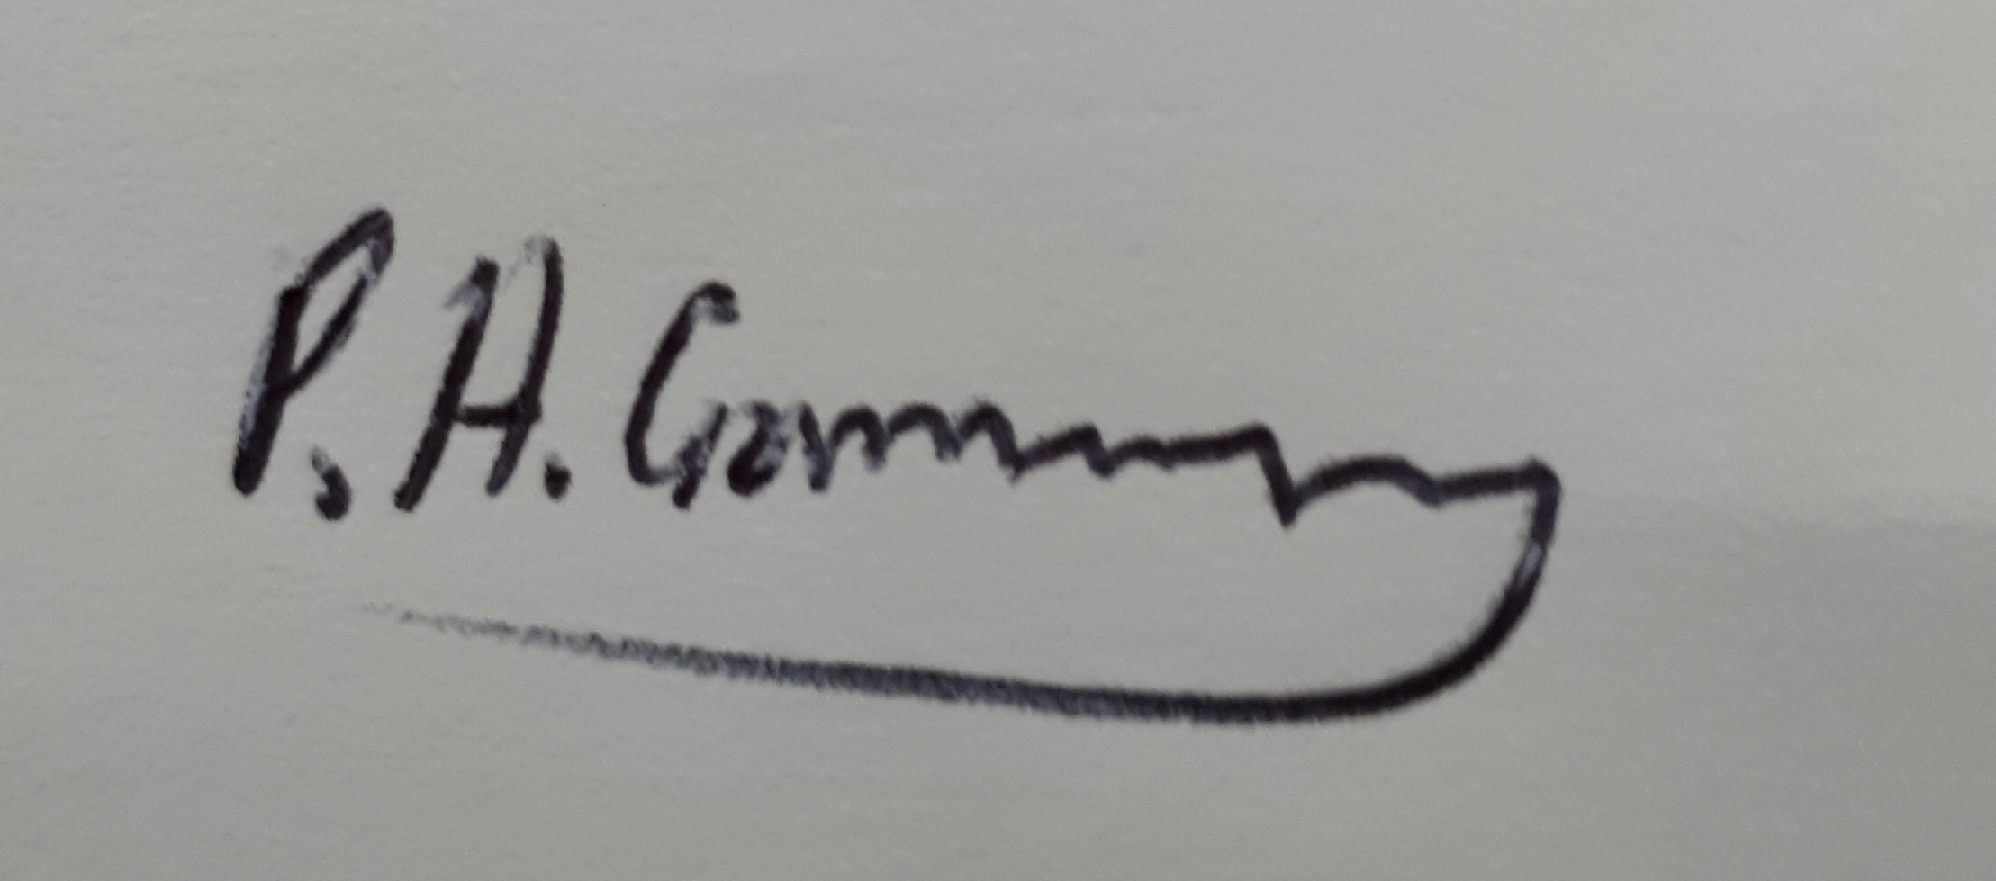 |  |  |  |  | Responsible manager’s signature:  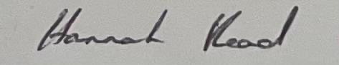
Print name: Philippa Garraway |  |  | Date: 07/04/24 |  | Print name: Hannah Read |  | Date: 09/04/2024

Assessment Guidance
- Eliminate | Remove the hazard wherever possible which negates the need for further controls | If this is not possible then explain why
- Substitute | Replace the hazard with one less hazardous | If not possible then explain why
- Physical controls | Examples: enclosure, fume cupboard, glove box | Likely to still require admin controls as well
- Admin controls | Examples: training, supervision, signage
- Personal protection | Examples: respirators, safety specs, gloves | Last resort as it only protects the individual
LIKELIHOOD | 5 | 5 | 10 | 15 | 20 | 25
 | 4 | 4 | 8 | 12 | 16 | 20
 | 3 | 3 | 6 | 9 | 12 | 15
 | 2 | 2 | 4 | 6 | 8 | 10
 | 1 | 1 | 2 | 3 | 4 | 5
 |  | 1 | 2 | 3 | 4 | 5
 |  | IMPACT

Risk process
- Identify the impact and likelihood using the tables above.
- Identify the risk rating by multiplying the Impact by the likelihood using the coloured matrix.
- If the risk is amber or red – identify control measures to reduce the risk to as low as is reasonably practicable.
- If the residual risk is green, additional controls are not necessary.
- If the residual risk is amber the activity can continue but you must identify and implement further controls to reduce the risk to as low as reasonably practicable.
- If the residual risk is red do not continue with the activity until additional controls have been implemented and the risk is reduced.
- Control measures should follow the risk hierarchy, where appropriate as per the pyramid above.
- The cost of implementing control measures can be taken into account but should be proportional to the risk i.e. a control to reduce low risk may not need to be carried out if the cost is high but a control to manage high risk means that even at high cost the control would be necessary.

Likelihood
1 | Rare e.g. 1 in 100,000 chance or higher
2 | Unlikely e.g. 1 in 10,000 chance or higher
3 | Possible e.g. 1 in 1,000 chance or higher
4 | Likely e.g. 1 in 100 chance or higher
5 | Very Likely e.g. 1 in 10 chance or higher

Impact |  | Health & Safety
1 | Trivial - insignificant | Very minor injuries e.g. slight bruising
2 | Minor | Injuries or illness e.g. small cut or abrasion which require basic first aid treatment even in self-administered.
3 | Moderate | Injuries or illness e.g. strain or sprain requiring first aid or medical support.
4 | Major | Injuries or illness e.g. broken bone requiring medical support >24 hours and time off work >4 weeks.
5 | Severe – extremely significant | Fatality or multiple serious injuries or illness requiring hospital admission or significant time off work.

