Risk Assessment
Risk Assessment for the activity of | Biological Sciences Society Bake Sale  Date: 20-11-23  Time: 10:00-15:00  Location: Building 85 Concourse |  | Date | 12-11-23
Group name | SUSU Biological Sciences Society | Assessor | Joshua Gahan
Supervisor | Joshua Gahan | Signed off | SUSU Activities Team

Level 2 food hygiene certificates need to be sent to the Activities team suactivities@soton.ac.uk (internal fundraiser) or the RAG team rag@susu.org (charity fundraiser) before the activity. Food hygiene training can be completed
PART A
(1) Risk identification |  |  |  | (2) Risk assessment |  |  |  | (3) Risk management
Hazard | Potential Consequences | Who might be harmed  (user; those nearby; those in the vicinity; members of the public) |  | Inherent |  |  |  | Residual |  |  | Further controls (use the risk hierarchy)
 |  |  |  | Likelihood | Impact | Score | Control measures (use the risk hierarchy) | Likelihood | Impact | Score
Serving and preparation of food | Allergies, food poisoning, and choking |  | All | 3 | 5 | 15 | - Homemade items to be avoided by those with allergies.  - Precautions should be made by those with appropriate food hygiene training (Level 2 +).  - Only order/buy food at establishments with appropriate food hygiene rating.  - Follow good food hygiene practices – no handling food when ill, tie back hair, wash hands and equipment regularly using warm water and cleaning products, and refrigerate necessary products. | 1 | 5 | 5 | - SUSU Food & Hygiene Level 2 course available for completion – requests made to Activities Team.  - Call for first aid/emergency services a required.  - Report incidents via SUSU incident report procedure.
Slips, trips, and falls | Physical injury |  | Event organisers and attendees | 2 | 4 | 8 | - All boxes and equipment to be stored away from main meeting area, e.g. stored under tables.  - Any cables to be organised as best as possible.  - Cable ties/to be used if necessary.  - Floors to be kept clear and dry, and visual checks to be maintained throughout the meeting by organisers.  - Extra vigilance will be paid to make sure that any spilled food products/objects are cleaned up quickly and efficiently in the area.  - Report any trip hazards to facilities teams/venue staff asap. If cannot be removed, mark off with hazard signs. | 1 | 4 | 4 | - Seek medical attention from SUSU reception/venue staff if in need.  - Contact facilities team via SUSU reception/venue staff.  - Contact emergency services if needed.  - All incidents are to be reported on the as soon as possible, ensuring the Duty Manager/Health and Safety Officer have been informed. Follow SUSU incident report policy.
Setting up of equipment, e.g. table and chairs | Bruising or broken bones from tripping over table and chairs |  | Meeting organisers and attendees | 2 | 3 | 6 | - Make stall operators aware of the potential risks and follow manual handling guidelines.  - Ensure that at least two people carry tables.  - Setting up tables will be done by organisers.  - Work in teams when handling other large and bulky items.  - Request tools to support with move of heavy objects – SUSU facilities/venue, e.g. hand truck, dolly, skates, etc.  - Make sure anyone with any pre-existing conditions isn’t doing any unnecessary lifting and they are comfortable. | 1 | 3 | 3 | - Seek assistance if in need of extra help from facilities staff/venue staff if needed.  - Seek medical attention from SUSU reception if in need.  - Contact emergency services if needed.  - All incidents are to be reported as soon as possible, ensuring the Duty Manager/Health and Safety Officer have been informed. Follow SUSU incident report policy.
Inadequate meeting space – overcrowding or not inclusive to all members | Physical injury, distress, and exclusion |  | Event organisers and attendees | 1 | 3 | 3 | - Committee check on room pre-booking, checks on space, lighting, access, tech available, etc.  - Ensure space meets needs of members, e.g. considering location & accessibility of space,  - Committee to consult members on needs and make reasonable adjustments where possible.  - A maximum of three representatives to be at the stall at any one time.  - Request that orderly ques are formed.  - Ensure all items are stored under tables and monitor area in front of stall to ensure this is clear.  - Ensure that organisers /volunteers do not block walkways when engaging with attendees.  - Follow instructions given by support staff/staff on directions and entry and exit points.  - Do not move tables if this has been placed for you by staff. | 1 | 3 | 3 | - Seek medical attention if problem arises.  - Liaise with SUSU reception/Activities Team on available spaces for meetings.  - Postpone meetings where space cannot be found.  - Look at remote meeting options for members.  - Committee WIDE training.
Medical emergency | Members may sustain injury /become unwell due to pre-existing medical conditions, sickness, or distress |  | Members | 3 | 5 | 15 | - Advise participants to bring their personal medication  - Members/Committee to carry out first aid if necessary and only if qualified and confident to do so.  - Contact emergency services as required 111/999.  - Contact SUSU reception/venue staff for first aid support. | 2 | 5 | 10 | - All incidents are to be reported as soon as possible, ensuring the Duty Manager/Health and Safety Officer have been informed.  - Follow SUSU incident report policy.
Insufficient fire safety awareness | If a fire alarm is triggered, people may not know where to go – crushing, falls, burns, and smoke inhalation arising from induced panic, reduced space in buildings and external walkways, obstructed fire exits, build-up of flammable materials, etc. |  | Members | 2 | 5 | 10 | - Ensure that members know where the nearest fire exist are and the meeting place is outside, should it be needed.  - Build-up of rubbish is to be kept to a minimum. Excess build-up is to be removed promptly and deposited in the designated areas. | 1 | 5 | 5 | - All incidents are to be reported as soon as possible, ensuring the Duty Manager/Health and Safety Officer have been informed. Follow SUSU incident report policy.  - Call emergency services and University Security. Emergency contact number for Campus Security: Tel: +44 (0)23 8059 3311 (Ext:3311).
Handling & storing money – charity fundraiser | Theft, individuals being mugged/robbed, or loss/misplacement leading to financial loss |  | Members, participants, and charity | 3 | 4 | 12 | Southampton RAG procedures will be followed:  - Charity event form completed, and RAG approval will be given.  - All food hygiene certificates and event risk assessment to be approved by Activities Team.  - Fundraising will be cashless through a JustGiving page. | 1 | 3 | 3 | - Liaise with SUSU Activities Team on best means of fundraising to ensure that there is no loss/misplacement of funds.
Adverse weather | Injury, illness, slipping, and burns |  | All who attend | 4 | 3 | 12 | - Lead organiser to check the weather are suitable for activities on the day.  - SUSU/UoS Facilities team checks of buildings and spaces prior to the event.  - Warn those attending to prepare by wearing appropriate clothing and footwear, e.g. via social media posts, email invites, etc.  - In the case of hot weather, organisers to advice participants to bring/wear appropriate level sunscreen, hydrate. | 4 | 1 | 4 | - If adverse weather is too extreme to be controlled, the event should ultimately be cancelled or postponed.

PART B – Action Plan
Risk Assessment Action Plan
Part no. | Action to be taken, incl. Cost | By whom | Target date |  | Review date | Outcome at review date
1 | Committee to send copies of all food hygiene training certificates to suactivities@soton.ac.uk | Yasmin Yardley | 18-11-23
2 | Committee members to create and display lists of ingredients (with allergens written in bold) at the stall | Yasmin Yardley | 20-11-23
3 | Committee to read and share SUSU Expect Respect Policy | Yasmin Yardley | 20-11-23
Responsible committee member signature:  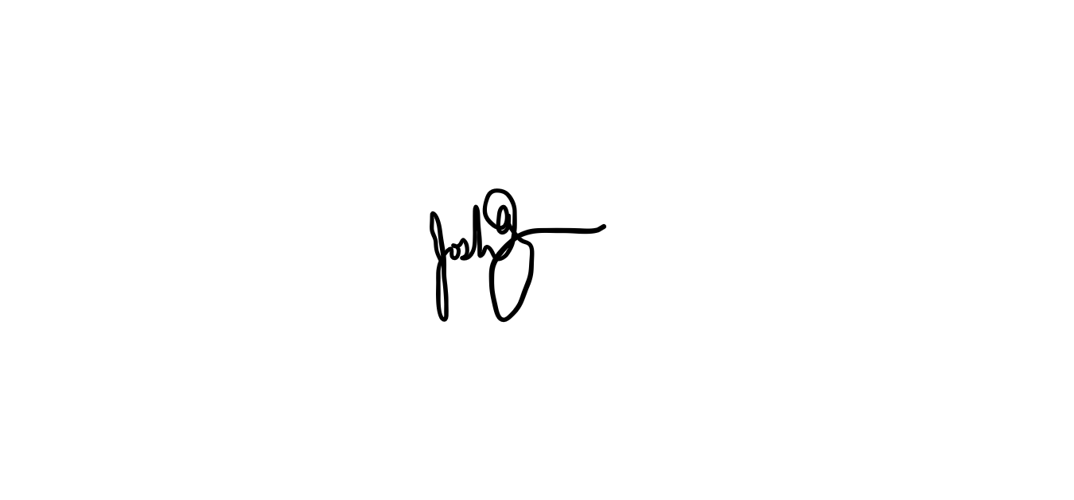 |  |  |  |  | Responsible committee member signature:
Print name: Joshua Gahan |  |  |  | Date: 12-11-23 | Print name: Charles Bush |  | Date: 13-11-23

Assessment Guidance
- Eliminate |  |  |  |  | Remove the hazard wherever possible which negates the need for further controls |  |  |  | If this is not possible then explain why
- Substitute |  |  |  |  | Replace the hazard with one less hazardous |  |  |  | If not possible then explain why
- Physical controls |  |  |  |  | Examples: enclosure, fume cupboard, glove box |  |  |  | Likely to still require admin controls as well
- Admin controls |  |  |  |  | Examples: training, supervision, signage
- Personal protection |  |  |  |  | Examples: respirators, safety specs, gloves |  |  |  | Last resort as it only protects the individual
LIKELIHOOD | 5 | 5 | 10 | 15 |  | 20 | 25
 | 4 | 4 | 8 | 12 |  | 16 | 20
 | 3 | 3 | 6 | 9 |  | 12 | 15
 | 2 | 2 | 4 | 6 |  | 8 | 10
 | 1 | 1 | 2 | 3 |  | 4 | 5
 |  | 1 | 2 | 3 |  | 4 | 5
 |  | IMPACT

Impact |  | Health & Safety
1 | Trivial - insignificant | Very minor injuries e.g. slight bruising
2 | Minor | Injuries or illness e.g. small cut or abrasion which require basic first aid treatment even in self-administered.
3 | Moderate | Injuries or illness e.g. strain or sprain requiring first aid or medical support.
4 | Major | Injuries or illness e.g. broken bone requiring medical support >24 hours and time off work >4 weeks.
5 | Severe – extremely significant | Fatality or multiple serious injuries or illness requiring hospital admission or significant time off work.

Likelihood
1 | Rare e.g. 1 in 100,000 chance or higher
2 | Unlikely e.g. 1 in 10,000 chance or higher
3 | Possible e.g. 1 in 1,000 chance or higher
4 | Likely e.g. 1 in 100 chance or higher
5 | Very Likely e.g. 1 in 10 chance or higher

Risk process
- Identify the impact and likelihood using the tables above.
- Identify the risk rating by multiplying the Impact by the likelihood using the coloured matrix.
- If the risk is amber or red – identify control measures to reduce the risk to as low as is reasonably practicable.
- If the residual risk is green, additional controls are not necessary.
- If the residual risk is amber the activity can continue but you must identify and implement further controls to reduce the risk to as low as reasonably practicable.
- If the residual risk is red do not continue with the activity until additional controls have been implemented and the risk is reduced.
- Control measures should follow the risk hierarchy, where appropriate as per the pyramid above.
- The cost of implementing control measures can be taken into account but should be proportional to the risk i.e. a control to reduce low risk may not need to be carried out if the cost is high but a control to manage high risk means that even at high cost the control would be necessary.

