Risk Assessment
Risk Assessment for the activity of | Biological Sciences Society Careers Fair  Location: Building 85, Highfield Campus, University of Southampton  Date: 13/11/23  Time: 1-6 pm |  | Date | 30/10/23
Unit/Faculty/Directorate | SUSU Biological Sciences Society | Assessor | Abby Woolston
Line Manager/Supervisor | Joshua Gahan | Signed off | SUSU Activities Team

PART A
(1) Risk identification |  |  | (2) Risk assessment |  |  |  | (3) Risk management
Hazard | Potential Consequences | Who might be harmed  (user; those nearby; those in the vicinity; members of the public) | Inherent |  |  |  | Residual |  |  | Further controls (use the risk hierarchy)
 |  |  | Likelihood | Impact | Score | Control measures (use the risk hierarchy) | Likelihood | Impact | Score
Fire | - A large number of people exiting one venue at one time  - Fire damage to equipment and property  - Harm to individuals | Students attending the Fair in Building 85. Members of Staff exhibiting or visiting as well as students and staff in the immediate vicinity of the venue | 1 | 5 | 5 | - Buildings fitted with fire detection equipment that is tested regularly and maintained  - Education Officers to brief exhibitors, speakers, alumni, student helpers and staff on fire safety and exits  - Fire extinguishers located in Building 85 can be used to assist with firefighting  - Site visit will be undertaken to check fire exits are clear and accessible prior to, and on the day, of the event  - Fire exits are clearly marked, maintained and will remain clear of obstructions during event  - Education Officers, staff and exhibitors informed of the evacuation procedures and assembly point | 1 | 3 | 3 | - All incidents are to be reported as soon as possible ensuring the duty manager/health and safety officer have been informed.  - Call emergency services and University Security:  - Emergency contact number for Campus Security:  - Tel: +44 (0)23 8059 3311  - (Ext:3311).
Slips, trips, and falls | - Individuals  injuring themselves  - Staff and exhibitors tripping when carrying/moving objects/equipment  - If raining, wet floors leading to slippery surface | Anyone attending the Fair as well as those in the vicinity that may be affected by more people than usual in the area | 2 | 3 | 6 | - Education Officers overseeing the set up and take down to ensure safe practices are followed  - Crowd control measures are in place to prevent overcrowding both in the venue and in the access routes  - Route and venue regularly maintained by UoS/SUSU staff  - Electrical cables installed to be secured with tape  - Exhibitors to be briefed on safe storage and tidiness in their area  - Wide aisles to be incorporated into stall plan to avoid overcrowding  - Trolleys are available to move items without anyone carrying heavy or awkward items to their stall  - Correct signage used if it is raining to ensure awareness if floors are slippery  - Toilets will be checked regularly, ensuring any potential slips due to water are avoided | 1 | 3 | 3 | - Seek medical attention from SUSU Reception/venue staff if in need  - Contact facilities team via SUSU reception/venue staff  - Contact emergency services if needed  - All incidents are to be reported on the as soon as possible ensuring the duty manager/health and safety officer have been informed. Follow SUSU incident report policy
Damage to University property | - Cost to University  - Someone hurting themselves in the process | Those in the vicinity | 2 | 3 | 6 | - Doors will be locked where needed  - Clear signage for visitors to ensure  appropriate access, limiting entry to other areas  - UoS staff will be available within building | 1 | 3 | 3 | - Seek medical attention if problem arises  - Seek support from facilities staff
Congestion / overcrowding | - People feeling hot and unwell  - People banging into each other  - Being unable to access the stalls | Those in the venue | 4 | 3 | 12 | - UoS staff and Education Officers on duty throughout the event monitoring capacity within venue and restricting access when capacity limit is reached  - Careful planning of stall location to prevent pressure points  - Seating provided at each stall and ample stall space allocated to each exhibitor to ensure overcrowding does not occur  - Clear stall plan in place  - Crowds managed by the team on an ongoing basis. Congested areas will be continually monitored, and the queue is stopped if overcrowding occurs | 2 | 2 | 4 | - Seek medical attention if problem arises  - With support from a SUSU Activities coordinator Inform UoS security team of the event (– on campus 3311, off campus 02380 593311. unisecurity@soton.ac.uk) and liaise with them on need for security teams on the day  - Security team may inform police of the event if required (e.g. marches)
Accidents, incidents, and injuries including sudden illness | - Student or members of staff become ill or injured and  require attention | Those in the venue | 2 | 4 | 8 | - Security staff are available via phone, to handle issues of safety and/or inappropriate behaviour  - First Aider is always on site and can be contacted via reception at any time  - For serious issues, phones are available to call 999  - Education Officers and staff to always have first aid contact and reception’s number.  - Access to the venue is available for those with mobility and/or disability issues via the main entrance to Building 85. Aisles between stalls will be kept as clear as possible – marketing materials, stand or exhibits will not protrude into the aisles  - Queue management methods will be applied to ensure that the queue remains safe and manageable. | 2 | 2 | 4 | - Any incidents will be reported via UoS reporting tools  - Contact emergency services if needed  - Organisers will, following the event, share relevant information on support/signpost via social media channels etc.  - All incidents are to be reported on the as soon as possible ensuring the duty manager/health and safety officer have been informed. Follow SUSU incident report policy  - Call 111/999 if needed
Waste disposal | - People tripping over rubbish  - Pollution | People in the vicinity | 3 | 2 | 6 | - University staff and society members will clear up after the event. Rubbish will be removed during the event to prevent excess rubbish building up and causing a hazard  - Cleaning equipment will be on hand for any spillages or breakages  - Waste bins will be provided for exhibitors and emptied on a rolling basis throughout the event if needed | 1 | 2 | 2 | - All incidents are to be reported as soon as possible ensuring the duty manager/health and safety officer have been informed.  - Follow SUSU incident report policy
Roads | - People being injured by cars and/or buses when trying to cross the road | People walking to and from the venues | 2 | 5 | 10 | - Safety precautions will be promoted to all who attend the event  - Signage across campus will direct attendees to the building using the safest route, e.g. using the zebra crossings  - Event speakers and stall holders will be informed of directions to the building from the nearest car park or bus station | 1 | 5 | 5 | - Incidents are to be reported on the as soon as possible ensuring the duty manager/health and safety officer have been informed.  - Follow SUSU incident report policy
Controversial views, verbal abuse or harassment | - People attending the talks or stalls feeling threatened or attacked | People attending the event | 2 | 3 | 6 | - Advice requested and received from SUSU and the university legal department  - Understood and recorded the trigger questions in Annex C of the Code of Practice on Freedom of Speech  - If required, the speakers will fill out a Practice of Freedom of Speech form and a case will be sent to the legal department | 1 | 3 | 3 | - With support from a SUSU Activities coordinator Inform UoS security team of the event -University Security 24 hours – on campus 3311, off campus 02380 593311.  - Contact emergency services if needed  - unisecurity@soton.ac.uk  - Inform UoS/SUSU communications team of the event- can brief others via SUSSED

PART B – Action Plan

Risk Assessment Action Plan
Part no. | Action to be taken, incl. Cost | By whom |  | Target date | Review date | Outcome at review date
1. | All external speakers and stall holders will be briefed on fire safety and exits on the day of the event. | The Education Officers |  | 13/11/23
2. | Stall plan to be made with ample space around them to avoid overcrowding, slips, trips and falls. | The Education Officers |  | 13/11/23
3. | Education Officers will arrive before the event and stay after to ensure the area is clear of rubbish and hazards. | The Education Officers |  | 13/11/23
4. | Clear signage will direct attendees to the building safely and ensure appropriate access to the different areas. | The Education Officers |  | 13/11/23
5. | All speakers and stall holders will be provided with a copy of this risk assessment. | The Education Officers |  | 13/11/23
Responsible manager’s signature:  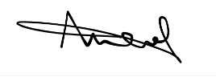 |  |  |  |  | Responsible manager’s signature:  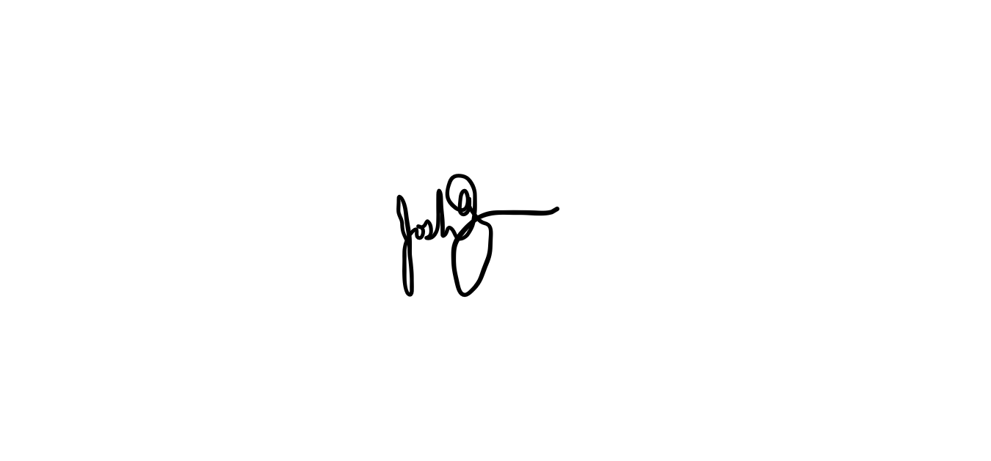
Print name: Abby Woolston |  |  | Date: 28/10/23 |  | Print name: Joshua Gahan |  | Date: 30/10/23

Assessment Guidance
- Eliminate | Remove the hazard wherever possible which negates the need for further controls | If this is not possible then explain why
- Substitute | Replace the hazard with one less hazardous | If not possible then explain why
- Physical controls | Examples: enclosure, fume cupboard, glove box | Likely to still require admin controls as well
- Admin controls | Examples: training, supervision, signage
- Personal protection | Examples: respirators, safety specs, gloves | Last resort as it only protects the individual
LIKELIHOOD | 5 | 5 | 10 | 15 | 20 | 25
 | 4 | 4 | 8 | 12 | 16 | 20
 | 3 | 3 | 6 | 9 | 12 | 15
 | 2 | 2 | 4 | 6 | 8 | 10
 | 1 | 1 | 2 | 3 | 4 | 5
 |  | 1 | 2 | 3 | 4 | 5
 |  | IMPACT
Likelihood
1 | Rare e.g., 1 in 100,000 chance or higher
2 | Unlikely e.g., 1 in 10,000 chance or higher
3 | Possible e.g., 1 in 1,000 chance or higher
4 | Likely e.g., 1 in 100 chance or higher
5 | Very Likely e.g., 1 in 10 chance or higher
Impact |  | Health & Safety
1 | Trivial - insignificant | Very minor injuries e.g., slight bruising
2 | Minor | Injuries or illness e.g., small cut or abrasion which require basic first aid treatment even in self-administered.
3 | Moderate | Injuries or illness e.g., strain or sprain requiring first aid or medical support.
4 | Major | Injuries or illness e.g., broken bone requiring medical support >24 hours and time off work >4 weeks.
5 | Severe – extremely significant | Fatality or multiple serious injuries or illness requiring hospital admission or significant time off work.

Risk process
- Identify the impact and likelihood using the tables above.
- Identify the risk rating by multiplying the Impact by the likelihood using the coloured matrix.
- If the risk is amber or red – identify control measures to reduce the risk to as low as is reasonably practicable.
- If the residual risk is green, additional controls are not necessary.
- If the residual risk is amber the activity can continue but you must identify and implement further controls to reduce the risk to as low as reasonably practicable.
- If the residual risk is red do not continue with the activity until additional controls have been implemented and the risk is reduced.
- Control measures should follow the risk hierarchy, where appropriate as per the pyramid above.
- The cost of implementing control measures can be taken into account but should be proportional to the risk i.e. a control to reduce low risk may not need to be carried out if the cost is high but a control to manage high risk means that even at high cost the control would be necessary.
I have read and understood the Biological Sciences Careers Fair risk assessment
Name | Signature and date | Name | Signature and date

