Risk Assessment
Risk Assessment for the activity of | REBALL (Reusable Paintballing) |  | Date | 31/08/23
Unit/Faculty/Directorate | Southampton Uni Paintball Club | Assessor | Callum Doak
Line Manager/Supervisor | President: Callum Doak | Signed off  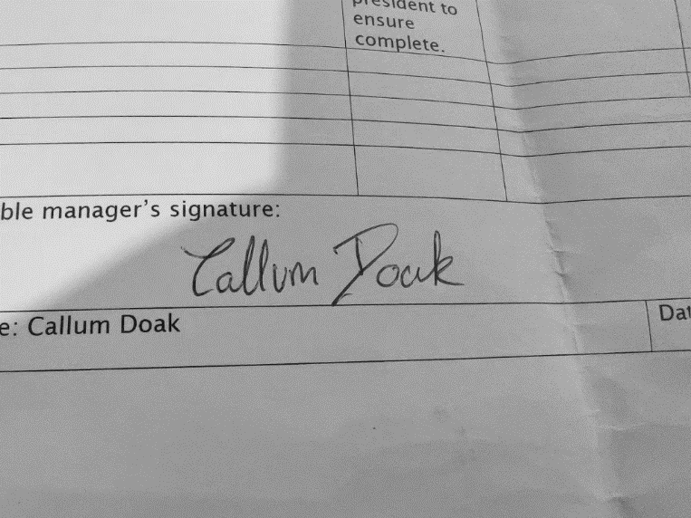

PART A
(1) Risk identification |  |  | (2) Risk assessment |  |  |  | (3) Risk management
Hazard | Potential Consequences | Who might be harmed  (user; those nearby; those in the vicinity; members of the public) | Inherent |  |  |  | Residual |  |  | Further controls (use the risk hierarchy)
 |  |  | Likelihood | Impact | Score | Control measures (use the risk hierarchy) | Likelihood | Impact | Score
Impact of Reballs to people. – Reball impact to Face. | Potential Severe Injury or death if shot in face without a mask. | Those inside the controlled area. | 3 | 5 | 15 | All activities will take place in a controlled environment (The cube) to ensure that no balls exit the prescribed area with any force.  Specifically using the Cube the society will use the double layered doors as an airlock, manned by a committee member to ensure no one outside of the area is exposed to risk.  ATSM approved Paintball Goggles MUST be warn at all times when the field is live.  All markers will be chronographed to ensure velocity is kept below 220 fps. | 4 | 1 | 4 | People are more likely to be shot in the face once masks are worn. But there is almost zero risk of injury to face once these are worn.  See Masks removed for details on procedure if accidental or purposeful removal on live field.
Impact of Reballs to people. – Reball impacts to rest of body. | Impacts will leave Bruising; the severity depends on the velocity of Reball. | Those within the controlled area. | 5 | 1 | 5 | To reduce potential bruising and pain of impact, markers will be chronographed before each event below 220 fps.  Random testing of velocity will be done through the event. | 5 | 1 | 5 | Reballs are going to leave bruises but that is something attending players recognise and consent to before starting the activity.
People removing goggles. | Impact to face without mask could result in blindness, loss of teeth or death. | Those within the controlled area. | 3 | 5 | 15 | A safety briefing will be conducted by the health & safety lead before the field becomes live outlining the potential consequences of mask removal.  Participants will be told to drop to the floor and cover their eyes and face and shout mask off if their mask does come off.  This will include warning them that a violation of this will lead to ejection from the event and a likely ban from future club activities.  If a mask is removed or accidently comes off. All referees are trained to immediately stop ongoing activities and if possible, put themselves between anyone and the person without a mask until it is put back on.
Goggles coming off accidently in a game. | Potential Severe Injury or death if shot in face without a mask. | Player. | 1 | 5 | 5 | Participants will be told to drop to the floor and cover their eyes and face and shout mask off if their mask does come off.  If a mask is removed or accidently comes off. All referees are trained to immediately stop ongoing activities and if possible, put themselves between anyone and the person without a mask until it is put back on. | 1 | 4 | 4 | When the correct procedure is adopted there is a very small time margin where the player is at risk (Before they are able to cover their face), Marshals and players are usually very quick to respond when this event occurs.
Markers still on when the field is no longer Live. | Similar risks to both forms of impact. | Those in the controlled area. | 3 | 5 | 15 | Health & Safety lead will ensure all barrel socks are in place, and markers have been turned off & degassed before calling the field dead. | 1 | 1 | 1 | With Barrel socks on, even if someone has forgotten to turn off a marker, there is little risk remaining.
Paintballs still in loader. | Normal Paintballs hidden in hoppers can be fired with reballs and cause a mess.  (All impacts are same as reballs and are evaluated above. There are no further risks due to the projectile type) | The Cube/Venue | 4 | 1 | 4 | All Hoppers to be properly cleared before attaching to Marker setups. | 1 | 1 | 1
Technical Equipment being hit. | Large potential financial cost of broken equipment.  Broken Glass could cause cuts or falling objects could cause injury. | The Cube/Venue | 2 | 2 | 4 | All players will be briefed to aim below the racking on the walls of the cube and not to deliberately aim for any lighting.  In testing, this was found to significantly reduce the risks of any bounces that could reach the lighting and also found that the energy of bounced balls was much lower and would not likely cause problems.  All markers chronoed below 220 FPS | 2 | 2 | 4
High Pressure Air Systems. | Burst disk venting causing injury due to freezing cold air | The user and or players immediately next to the bottle. | 2 | 3 | 6 | Cylinders inspected every 5 years by qualified professional and certified safe. Only competent society individuals having had suitable training will be permitted to make changes to air systems. | 1 | 3 | 3
High Pressure Air Systems. | Injury from bottle  being forced out of  fill system | Person filling the air system | 3 | 2 | 6 | No member of the club is permitted to fill air systems without having had a suitable training session. This training covers the details in the UK Paintball Sport Federation Guidelines HPA-1 document. | 2 | 2 | 4
Trips & Slips | From Bruises & Grazes up to broken bones and sprains from falling awkwardly, which can be affected by the weight of the Paintball Marker | The user. | 3 | 3 | 9 | Players without suitable knee protection will be advised not to deliberately slide, dive or sprint flat-out, and will be told to exercise caution to avoid slipping during gameplay.  Floors will be checked before starting to check they are clean and dry to lower the risk of slipping. | 2 | 3 | 6
Unexpected Visitors. | Members of public could be hit if they enter the risk area. They are also unlikely to have masks so could be in peril of being shot without a mask. (See above) | Members of Public | 2 | 5 | 10 | We are going to use the double doors of the cube as an airlock, manned by a committee member with some spare masks they will be able to have people enter and exit the controlled zone safely without the risk of reballs being shot into the foyer or members of public trying to walk into the cube whilst a game is in progress.  Signs outside will also inform people how this process works and how to enter safely (with the permission of the airlock manager) | 2 | 1 | 2 | For future events we will also host these as a ticketed event so we have more of an exact idea of who is attending and which timeslots they wish to join us.
Slipping Over Reballs | Same as slips & trips. | Player | 4 | 1 | 4 | We will sweep up excess reballs at regular intervals between games so that the number of reballs on the floor is kept to a minimum. | 3 | 1 | 3
General Health & Safety | Fitness & First Aid | Player | 1 | 2 | 2 | All sites have at least one registered first  aider present on site at all times. All  players must declare any known injury or  another ailment that may prevent them  participating in the event(s).  All first aiders should be made aware of  players who may require specialist  treatment. | 1 | 2 | 2

PART B – Action Plan

Risk Assessment Action Plan
Part no. | Action to be taken, incl. Cost | By whom | Target date | Review date | Outcome at review date
1 | Signs placed at the entrance to venue. | Health & Safety Lead | Day of Event
2 | Material placed across the bottom of seating. & Panels placed in front of gaps in retractable seating | By Susu Maintenance. | Before Event
3 | Member of committee placed outside entrance to venue to control entry & provide facial protection.  And the upper balcony of the cube is locked off. | Health & Safety Lead | Day of Event
4 | Member of committee/Referee will check mask is secure & tight. | Referee/ Committee Member | Day of Event
5 | Health & Safety Lead will conduct a full safety briefing of all assembled players.  The following points MUST be addressed:  - Masks must be warn at all time until the Health and Safety lead has concluded the area is safe again and called a “Dead Field”  - What to do if masks come off accidently.  - Avoid Slips, Trips & Falls  - Markers should only be aimed below the racking on the cube wall to prevent bounces towards Cube technical equipment.  - Players should try to avoid very close-range shooting.  - No players will be allowed to participate if suspected that they are under the influence of alcohol.  - No-one other than committee is to go on the stage.(And that is to be avoided)  - Dives & Slides are not recommended.  - The location of the first aid kit is pointed out. | Health & Safety Lead | Day of Event
6 | Health & Safety Lead will check all members have barrel socks on markers and that everyone within controlled area is wearing a mask | Health & Safety Lead | Day of Event
7 | Lead will shout “Live Field” when announcing that the area is live and is now a risk zone. | Health & Safety Lead | Day of Event
8 | Markers will be chronographed at the start of the event and randomly throughout. The maximum velocity is 200 feet per second. | Health & Safety Lead | Day of Event
9 | If a mask is removed:  All referees will call a stop to the game, any referees nearby will put themselves between the player and any reballs. | Referees | Day of Event
10 | Every game or two the referees will sweep the floor to push reballs away from the playing area to decrease the slip hazard that they present. | Referees | Day of Event
11 | Before calling a “dead field” Health & Safety lead will ensure all markers have barrel socks, are turned off and degassed. | Health & Safety Lead | Day of Event
Responsible manager’s signature:  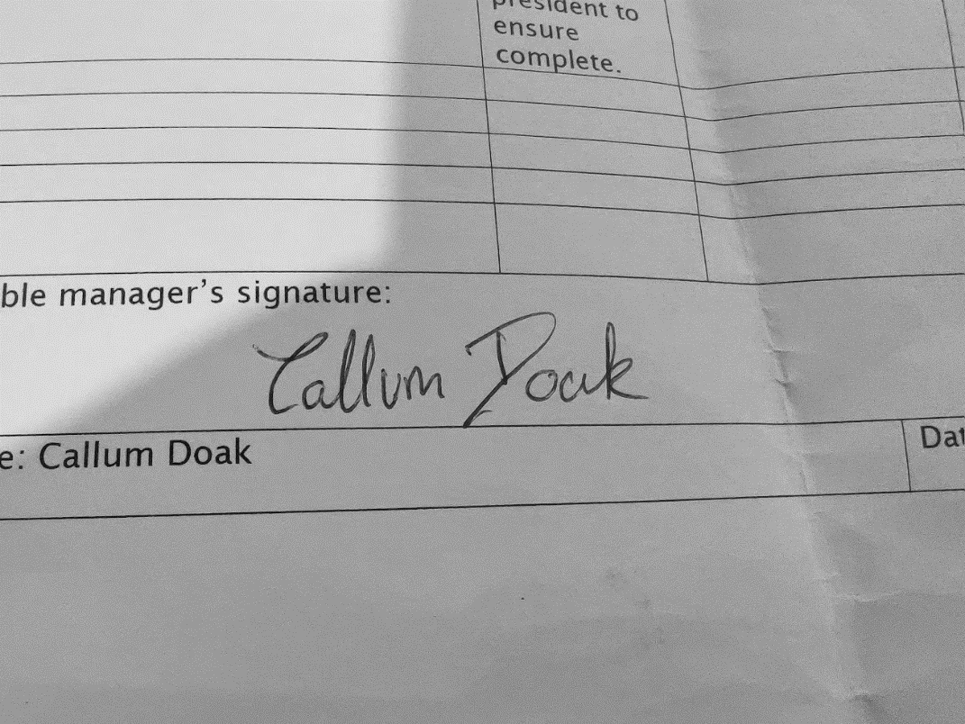 |  |  |  | Responsible manager’s signature:  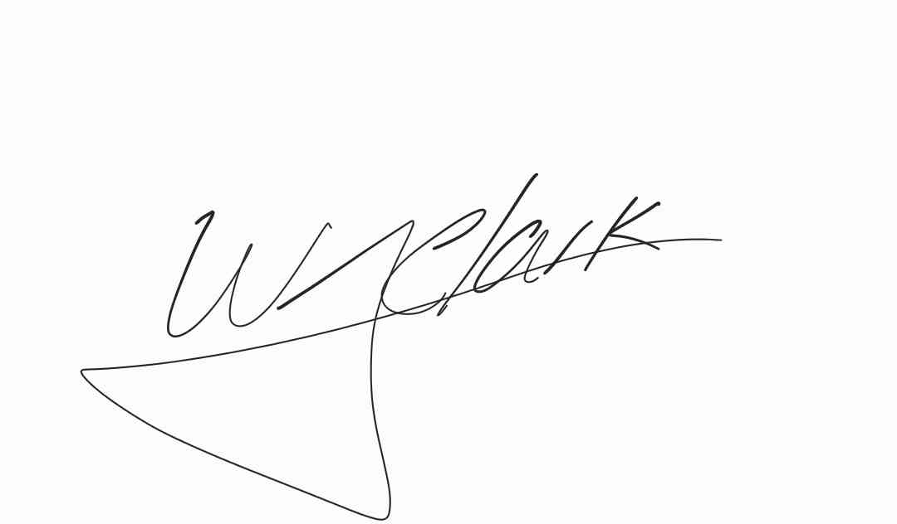
Print name: Callum Doak |  |  | Date:01/09/23 | Print name: Will Clark |  | Date:09/09/23

Assessment Guidance
- Eliminate | Remove the hazard wherever possible which negates the need for further controls | If this is not possible then explain why
- Substitute | Replace the hazard with one less hazardous | If not possible then explain why
- Physical controls | Examples: enclosure, fume cupboard, glove box | Likely to still require admin controls as well
- Admin controls | Examples: training, supervision, signage
- Personal protection | Examples: respirators, safety specs, gloves | Last resort as it only protects the individual
LIKELIHOOD | 5 | 5 | 10 | 15 | 20 | 25
 | 4 | 4 | 8 | 12 | 16 | 20
 | 3 | 3 | 6 | 9 | 12 | 15
 | 2 | 2 | 4 | 6 | 8 | 10
 | 1 | 1 | 2 | 3 | 4 | 5
 |  | 1 | 2 | 3 | 4 | 5
 |  | IMPACT

Impact |  | Health & Safety
1 | Trivial - insignificant | Very minor injuries e.g. slight bruising
2 | Minor | Injuries or illness e.g. small cut or abrasion which require basic first aid treatment even in self-administered.
3 | Moderate | Injuries or illness e.g. strain or sprain requiring first aid or medical support.
4 | Major | Injuries or illness e.g. broken bone requiring medical support >24 hours and time off work >4 weeks.
5 | Severe – extremely significant | Fatality or multiple serious injuries or illness requiring hospital admission or significant time off work.
Likelihood
1 | Rare e.g. 1 in 100,000 chance or higher
2 | Unlikely e.g. 1 in 10,000 chance or higher
3 | Possible e.g. 1 in 1,000 chance or higher
4 | Likely e.g. 1 in 100 chance or higher
5 | Very Likely e.g. 1 in 10 chance or higher
Risk process
- Identify the impact and likelihood using the tables above.
- Identify the risk rating by multiplying the Impact by the likelihood using the coloured matrix.
- If the risk is amber or red – identify control measures to reduce the risk to as low as is reasonably practicable.
- If the residual risk is green, additional controls are not necessary.
- If the residual risk is amber the activity can continue but you must identify and implement further controls to reduce the risk to as low as reasonably practicable.
- If the residual risk is red do not continue with the activity until additional controls have been implemented and the risk is reduced.
- Control measures should follow the risk hierarchy, where appropriate as per the pyramid above.
- The cost of implementing control measures can be taken into account but should be proportional to the risk i.e. a control to reduce low risk may not need to be carried out if the cost is high but a control to manage high risk means that even at high cost the control would be necessary.

