Risk Assessment
Risk Assessment for the activity of | SUIIHC Christmas Roller Disco On the 6/12/24 |  | Date | 4/11/24
Unit/Faculty/Directorate | SUSU AU | Assessor | Christopher Ansell
President/Captain Name/2nd Committee Member | Niamh Yates | Signed off (SUSU Staff)
Club or Team Information | For a Christmas Social this year, Southampton University Ice & Inline Hockey Club are holding a roller disco in The Cube. This will be from 19:30 – 21:00 and will involve skating with music playing. There are risks involved with skating but the majority of attendees will be proficient so slips and falls will be minimal. There will be no alcohol involved.  For further information on risk, please visit - https://www.hse.gov.uk/simple-health-safety/risk/index.htm

PART A
(1) Risk identification |  |  | (2) Risk assessment |  |  |  | (3) Risk management
Hazard | Potential Consequences | Who might be harmed  (user; those nearby; those in the vicinity; members of the public) | Inherent |  |  |  | Residual |  |  | Further controls (use the risk hierarchy)
 |  |  | Likelihood | Impact | Score | Control measures (use the risk hierarchy) | Likelihood | Impact | Score
Activity
Equipment (Roller Skates) | Cut/abrasion/ bruising from damaged or not properly fitted skates | All participants. | 2 | 2 | 4 | Check all equipment prior to use.  Those leading the session to remain vigilant to ensure participants are using the equipment as demonstrated. | 1 | 1 | 2 | Seek medical attention if problem arises, first aider(s) will be present.  Any incidents will be reported as soon as possible ensuring duty manager/health and safety officers have been informed. SUSU incident report policy will be followed.
Jewellery and other objects in pockets | Entrapment/ things getting stuck, collisions with others that could cause cuts or bruises. | All participants and organisers/staff. | 2 | 2 | 4 | Participants asked to remove jewellery and objects from pockets prior to joining in.  Those leading the session will ensure this has been done. | 1 | 2 | 2 | If any injury occurs, seek medical attention.  If severe, call 999 in an emergency.  Any incidents need to be reported as soon as possible ensuring duty manager/health and safety officers have been informed. Follow SUSU incident report policy.
Participant’s over-exerting themselves | Muscle injury – strains and pulls. | All participants | 1 | 3 | 9 | Warmup before beginning the skate | 2 | 3 | 6 | If any injury occurs, seek medical attention.  If severe, call 999 in an emergency (although unlikely for muscular)  Any incidents need to be reported as soon as possible ensuring duty manager/health and safety officers have been informed. Follow SUSU incident report policy.
Fire | Smoke inhalation, burns and more severe. Risk of extreme harm. | All participants and organisers/staff and spectators | 1 | 5 | 5 | Those leading the session must ensure they are aware of and fully understand the venue or locations fire procedures.  Those leading must make sure that all exit routes are clearly highlighted and report any issues immediately to the venue.  Highlight to all the participants the nearest emergency exit routes at the start of a session, and the importance of leaving calmly in case of an emergency. | 1 | 4 | 4 | In case of an emergency, please pull nearest fire alarm and ensure all participants leave the venue calmly and safely.  Once in a safe position to do so, call the emergency services on 999.  Any incidents need to be reported as soon as possible ensuring duty manager/health and safety officers have been informed. Follow SUSU incident report policy.
Slips, trips and falls | Soft tissue injury e.g., sprain, bruising. Potential broken ankle or other breaks i.e. wrists | All participants | 3 | 3 | 9 | Check surface in the cube to make sure there are no bumps when skating.  Ensure no one is skating too fast or recklessly. | 1 | 3 | 3 | If the injury is serious and participant in a lot of pain or discomfort, seek medical attention immediately.  Call 999 in an emergency.  Any incidents need to be reported as soon as possible ensuring duty manager/health and safety officers have been informed. Follow SUSU incident report policy.
Participant Attire | Injury can occur if people are not wearing attire appropriate to the sport or activity. | All participants | 1 | 3 | 3 | Ensure all participants are wearing suitable clothing for skating. | 1 | 3 | 3 | If the injury is serious and participant in a lot of pain or discomfort, seek medical attention immediately.  Call 999 in an emergency.  Any incidents need to be reported as soon as possible ensuring duty manager/health and safety officers have been informed. Follow SUSU incident report policy.
Medical emergency | Members may sustain injury /become unwell from pre-existing medical conditions  Sickness  Distress | All participants | 2 | 5 | 15 | Advise participants; to bring their personal medication  Members/Committee to carry out first aid if necessary and only if qualified and confident to do so  Contact emergency services as required 111/999  Contact SUSU Reception/Venue staff for first aid support | 2 | 5 | 15 | Incidents are to be reported on the as soon as possible ensuring the duty manager/health and safety officer have been informed.  Follow SUSU incident report policy
Southampton Sport Facilities
Facility defects, including, Lighting, Heating, Fire, Bomb Threat (unidentified package), fire exit blocked  Wet floors, uneven surfaces or defects. Extreme heat, fire exits blocked | Causing Slip, trip or Falls.  Minor bruising, sprain, fracture, dislocation, concussion, dehydration, entrapment.  Person or persons falling over or into objects and/or each other, due to fire exit blocked | All Participants | 2 | 3 | 6 | Everyone to ensure they do visual checks of the cube before the session starts and report anything to the Southampton Sport Staff.  If surface is deemed unsafe then the session is not to go ahead.  If the area can be sectioned off then play can continue avoiding this area, this will be determined by the club.  Excessive Heat  Ensure participants take on enough water in extreme heat. Report heat to Southampton Sport Staff.  Fire exit blocked  Everyone to ensure they do not put anything in front of fire exits.  Everyone to ensure they remove anything put in front of fire exits.  Clear walkways are maintained in all areas accessing the fire exits. | 2 | 2 | 4 | QR codes to report any defects to the Southampton Sport Staff.  Injuries to be reported to the Southampton Sport Staff and via the SUSU reporting system.
Equipment provided by Southampton Sport failure | Minor bruising, sprain, fracture, dislocation, concussion, | Participants in the activity, referees, spectators | 2 | 3 | 6 | Everyone to report equipment failure to the Southampton Sport Staff.  If equipment is unsafe, take it out of action. | 2 | 2 | 4 | QR code to report any equipment failure to the Southampton Sport Staff.  Injuries to be reported to the Southampton Sport Staff and via the SUSU reporting system.
Violent or aggressive behaviour or actions towards staff | Inflicting physical injury, vandalising property, financial loss or reputation | Staff | 1 | 3 | 3 | Abiding by facility rules, everyone should treat people with respect.  In serious circumstances seek assistance. | 2 | 2 | 4 | Make Southampton Sport Staff aware, call security.  Injuries to be reported to the Southampton Sport Staff ad via the SUSU reporting system.  Contact Report and Support Report + Support - University of Southampton
Inadequate meeting space- overcrowding, not inclusive to all members | Physical injury, distress, exclusion | Event organisers and attendees | 1 | 3 | 3 | Committee check on room pre-booking, checks on space, lighting, access, tech available  Ensure space meets needs of members e.g., considering location & accessibility of space  Committee to consult members on needs and make reasonable adjustments where possible | 1 | 3 | 3 | Seek medical attention if problem arises  Liaise with SUSU reception/activities team on available spaces for meetings  Postpone meetings where space cannot be found  Look at remote meeting options for members  Committee WIDE training
PART B – Action Plan
Risk Assessment Action Plan
Part no. | Action to be taken, incl. Cost | By whom | Target date |  | Review date | Outcome at review date
1 | Organise appropriate roller and safety equipment from SUSU. | Responsible manager as signed below | 29/11/24 |  | N/A
2 | Ensure a first aider is on site during the event. | Responsible manager as signed below | 29/11/24 |  | N/A
3 | Ensure some experienced members of SUIIHC act as support for novice skaters. | Responsible manager as signed below | 29/11/24 |  | N/A
4 | Maintain a maximum 43 skaters at one time at event. | Responsible manager as signed below | 6/12/24 |  | N/A
Responsible manager’s signature:  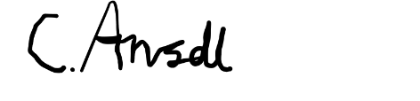 |  |  |  |  | Responsible manager’s signature:  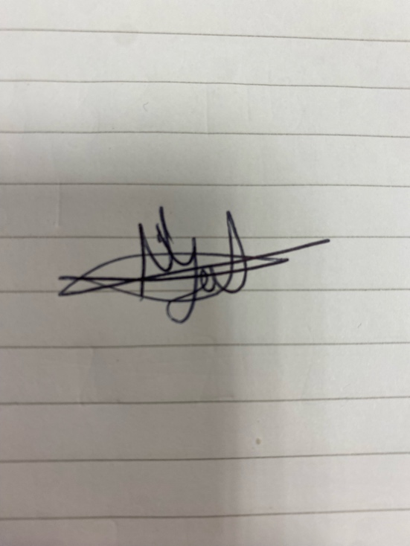
Print name: Christopher Ansell |  |  |  | Date:1/11/24 | Print name: Niamh Yates |  | Date:4/11/24

Assessment Guidance
- Eliminate | Remove the hazard wherever possible which negates the need for further controls | If this is not possible then explain why
- Substitute | Replace the hazard with one less hazardous | If not possible then explain why
- Physical controls | Examples: enclosure, fume cupboard, glove box | Likely to still require admin controls as well
- Admin controls | Examples: training, supervision, signage
- Personal protection | Examples: respirators, safety specs, gloves | Last resort as it only protects the individual
LIKELIHOOD | 5 | 5 | 10 | 15 | 20 | 25
 | 4 | 4 | 8 | 12 | 16 | 20
 | 3 | 3 | 6 | 9 | 12 | 15
 | 2 | 2 | 4 | 6 | 8 | 10
 | 1 | 1 | 2 | 3 | 4 | 5
 |  | 1 | 2 | 3 | 4 | 5
 |  | IMPACT

Impact |  | Health & Safety
1 | Trivial - insignificant | Very minor injuries e.g. slight bruising
2 | Minor | Injuries or illness e.g. small cut or abrasion which require basic first aid treatment even in self-administered.
3 | Moderate | Injuries or illness e.g. strain or sprain requiring first aid or medical support.
4 | Major | Injuries or illness e.g. broken bone requiring medical support >24 hours and time off work >4 weeks.
5 | Severe – extremely significant | Fatality or multiple serious injuries or illness requiring hospital admission or significant time off work.
Risk process
- Identify the impact and likelihood using the tables above.
- Identify the risk rating by multiplying the Impact by the likelihood using the coloured matrix.
- If the risk is amber or red – identify control measures to reduce the risk to as low as is reasonably practicable.
- If the residual risk is green, additional controls are not necessary.
- If the residual risk is amber the activity can continue but you must identify and implement further controls to reduce the risk to as low as reasonably practicable.
- If the residual risk is red do not continue with the activity until additional controls have been implemented and the risk is reduced.
- Control measures should follow the risk hierarchy, where appropriate as per the pyramid above.
- The cost of implementing control measures can be taken into account but should be proportional to the risk i.e. a control to reduce low risk may not need to be carried out if the cost is high but a control to manage high risk means that even at high cost the control would be necessary.

Likelihood
1 | Rare e.g. 1 in 100,000 chance or higher
2 | Unlikely e.g. 1 in 10,000 chance or higher
3 | Possible e.g. 1 in 1,000 chance or higher
4 | Likely e.g. 1 in 100 chance or higher
5 | Very Likely e.g. 1 in 10 chance or higher

