Risk Assessment
Risk Assessment for the activity of | SUSWO Weekly Rehearsals 2023/24 |  | Date | 10/09/2023
Unit/Faculty/Directorate | Southampton University Symphonic Wind Orchestra | Assessor | Callum Taylor-Barry
Line Manager/Supervisor | VP Activities | Signed off | 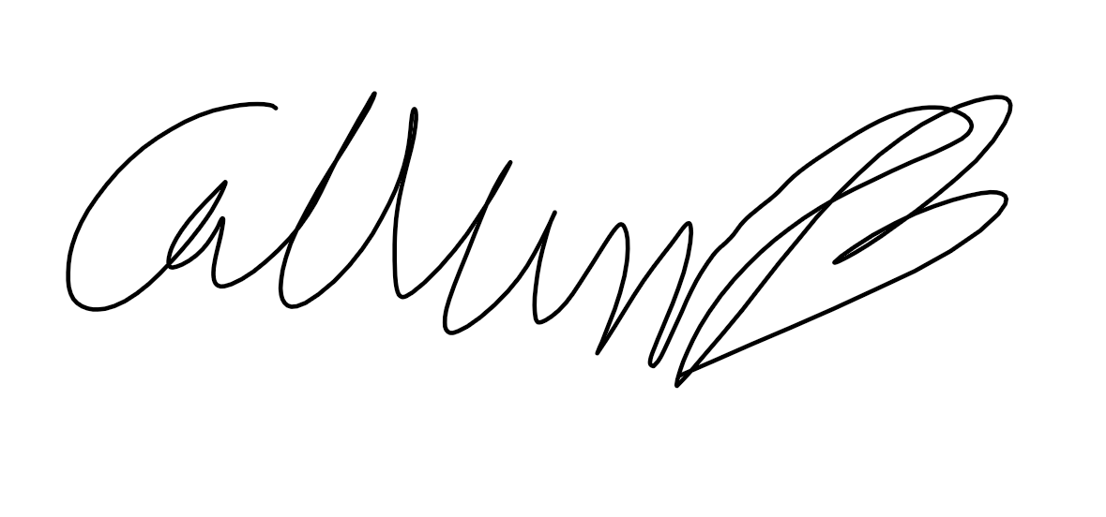

PART A
(1) Risk identification |  |  | (2) Risk assessment |  |  |  | (3) Risk management
Hazard | Potential Consequences | Who might be harmed?  (User; those nearby; those in the vicinity; members of the public) | Inherent |  |  |  | Residual |  |  | Further controls (use the risk hierarchy)
 |  |  | Likelihood | Impact | Score | Control measures (use the risk hierarchy) | Likelihood | Impact | Score
REHEARSAL

Moving tables, chairs, instruments, music, and music stands | - Incorrect lifting technique can put strain on the back and shoulders.  - Dropping heavy items can also cause harm.  - Tripping whilst carrying items that prevent a clear view.  - Falling moving equipment on stairs. | Those moving equipment and those in the vicinity. | 3 | 4 | 12 | - Large and heavy things to be moved by more than 1 person- seek support from SUSU facilities/venue staff as needed  - Use lifts where possible for heavy items, where not possible extreme caution to be used and additional members should be on hand to assist  - Ensure that every carrier of equipment knows proper lifting techniques to move heavy items.  - Do not allow people with known back injuries or muscle strains to help.  - Make sure someone accompanies carrier of objects who has a clear view of the path.  - Making sure people aren’t too close before moving | 3 | 1 | 3 | Advise anyone who is intending on lifting heavy equipment to self-assess their capability when lifting and to remove themselves from the task if they do not believe they are well enough to complete it.  Seek Medical attention as needed. E.g. SUSU Reception, 111, 999  All incidents are to be reported as soon as possible ensuring the duty manager/health and safety officer have been informed.  Follow SUSU incident report policy
Hitting people with instruments whilst playing/dropping instruments | - Damage to instruments  - Injury to surrounding people  - Damage to space being used | Those in the vicinity | 4 | 2 | 8 | - Make sure everyone is spaced out as much as possible so people can move around as much as possible  - Larger instruments/ instruments that move a lot (trombones) are given extra space  - Instruments to be put in case or safely out of the way when not in use  - Nothing to be kept on the floor unless essential | 1 | 1 | 1 | Committee to ensure room booking is adequate with enough space to accommodate larger instruments. Request room changes as needed.  Seek medical attention if an accident occurs and is required.
Setting up/dismantling instruments and stands | - Trapping fingers in stands or other items  - Damaging equipment  - Dropping equipment on feet/another person | Those setting up and members nearby or assisting | 5 | 4 | 20 | - Teach members how to safely set up specific items and don’t allow untrained members to assist  - Committee to ensure adequate time for set up and pack down is planned for /allocated when bookings are made  - All screws should be tightened fully when setting up and when packing away, to avoid unexpected movement of parts | 2 | 3 | 6 | Committee to ensure only those with experience to set up set instruments.  Seek Medical attention as needed. E.g. SUSU Reception, 111, 999  All incidents are to be reported ASAP ensuring the duty manager has been informed.  Follow SUSU incident report policy
Tripping over equipment including wires, instruments, and instrument cases | Tripping over equipment and causing injury | Those in the vicinity | 5 | 4 | 20 | - Any cables to be organised as best as possible  - Cable ties/to be used if necessary  - Hazardous sections to be blocked off e.g. using chairs & signage  - Ensure that instruments are kept in their case when not being played.  - Nothing to be kept on floor unless essential | 2 | 2 | 4 | Seek Medical attention as needed. E.g. SUSU Reception, 111, 999  All incidents are to be reported ASAP ensuring the duty manager has been informed.  Follow SUSU incident report policy
Consistent (intentional) loud noise | Hearing Damage | Those regularly in the rehearsals | 5 | 3 | 15 | - Recommend earphones are used by affected members  - Position musicians appropriately so direct exposure is minimised  - Mutes/screens utilised if/where appropriate  - Avoid use of small, confined spaces | 2 | 2 | 4 | Not Required
Transport of equipment / people | - Muscle strain/sprain loading equipment  - Traffic accident resulting from equipment obstructing view  - Injury resulting from unsecured equipment being transported | Those loading or in any vehicle transporting | 4 | 4 | 16 | - Any equipment being transported by vehicle being appropriately strapped down  - Any equipment to not obscure any view that is legally required and driver to be comfortable, using a banksman where necessary  - If using van/minibus, the driver to be appropriately trained and insured  - Any heavy items to be carried by at least 2 people, or using trolley/lift etc where possible | 2 | 2 | 4 | Report any accident as required.  Follow SUSU incident report policy  Call emergency services if required.
Unfamiliar spaces – steps / raised flooring | Trips and falls causing injury | Performers/anyone new to the space | 5 | 3 | 15 | - All members to be shown the space before starting and steps to be pointed out, with players positioned so they are unlikely to fall  - If any raised areas/steps are not clearly marked, make venue caretaker aware and mark out where possible | 2 | 3 | 6 | Make sure people only enter necessary areas of the venue to reduce the likelihood of  coming across unknown  area/trip hazards.

PART B – Action Plan

Risk Assessment Action Plan
Part no. | Action to be taken, incl. Cost | By whom | Target date | Review date | Outcome at review date
1 | Separate risk assessment to be made for tour (alongside SUSO and Sinfonietta) | Tour Secretary (SUSO and Sinf included) | 01/04/23 | Annually | Appropriate prevention of risks
2 | Risk assessments to be made for any individual activities which still have high residual risk | Social Secretary | One week before activity | For each activity | Appropriate prevention of risks
3 | Check room bookings are adequate | President | 01/09/23 | 04/09/23 | Appropriate block bookings in place. Continue to check over room bookings outside of standard block bookings, as well as concert venues.
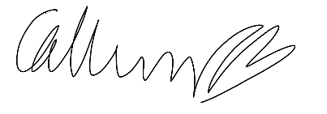  Responsible manager’s signature: |  |  |  | 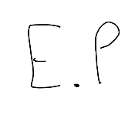  Responsible manager’s signature:
Print name: Callum Taylor-Barry |  |  | Date: 10/09/2023 | Print name: Ellie Palmer |  | Date: 10/09/2023

Assessment Guidance
- Eliminate | Remove the hazard wherever possible which negates the need for further controls | If this is not possible then explain why
- Substitute | Replace the hazard with one less hazardous | If not possible then explain why
- Physical controls | Examples: enclosure, fume cupboard, glove box | Likely to still require admin controls as well
- Admin controls | Examples: training, supervision, signage
- Personal protection | Examples: respirators, safety specs, gloves | Last resort as it only protects the individual
LIKELIHOOD | 5 | 5 | 10 | 15 | 20 | 25
 | 4 | 4 | 8 | 12 | 16 | 20
 | 3 | 3 | 6 | 9 | 12 | 15
 | 2 | 2 | 4 | 6 | 8 | 10
 | 1 | 1 | 2 | 3 | 4 | 5
 |  | 1 | 2 | 3 | 4 | 5
 |  | IMPACT

Impact |  | Health & Safety
1 | Trivial - insignificant | Very minor injuries e.g. slight bruising
2 | Minor | Injuries or illness e.g. small cut or abrasion which require basic first aid treatment even in self-administered.
3 | Moderate | Injuries or illness e.g. strain or sprain requiring first aid or medical support.
4 | Major | Injuries or illness e.g. broken bone requiring medical support >24 hours and time off work >4 weeks.
5 | Severe – extremely significant | Fatality or multiple serious injuries or illness requiring hospital admission or significant time off work.
Risk process
- Identify the impact and likelihood using the tables above.
- Identify the risk rating by multiplying the Impact by the likelihood using the coloured matrix.
- If the risk is amber or red – identify control measures to reduce the risk to as low as is reasonably practicable.
- If the residual risk is green, additional controls are not necessary.
- If the residual risk is amber the activity can continue but you must identify and implement further controls to reduce the risk to as low as reasonably practicable.
- If the residual risk is red do not continue with the activity until additional controls have been implemented and the risk is reduced.
- Control measures should follow the risk hierarchy, where appropriate as per the pyramid above.
- The cost of implementing control measures can be taken into account but should be proportional to the risk i.e. a control to reduce low risk may not need to be carried out if the cost is high but a control to manage high risk means that even at high cost the control would be necessary.

Likelihood
1 | Rare e.g. 1 in 100,000 chance or higher
2 | Unlikely e.g. 1 in 10,000 chance or higher
3 | Possible e.g. 1 in 1,000 chance or higher
4 | Likely e.g. 1 in 100 chance or higher
5 | Very Likely e.g. 1 in 10 chance or higher

